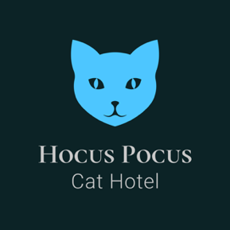 | Hocus Pocus Cat Hotel  2 Dalhams, Poole Street,  Cavendish  Suffolk  CO10 8BE  07922 665131  joanne@hocuspocuscathotel.com

Existing Customer Booking Form

Arrival Date & Time: |  | Departure Date  & Time:
Owners Name:

Cat(s) Name:

Any changes contact details, Emergency Contacts or Veterinary Practice?
Any changes regarding cat’s food?

Details of Cat 1
Cat’s Name:
Is your cat insured? Name of Insurance Company:
Name of Flea Treatment:  i.e. Prinovox, Advocate, etc.. |  | Date last applied:
Name of Worming Treatment:  i.e. Milbemax, Drontal etc. |  | Date last applied:
If evidence of fleas or worms are found, treatment will be sought from a vet and you will be liable for all costs. please refer to my Terms and Conditions for full details.

Details of Cat 2
Cat’s Name:
Insured?
Name of Flea Treatment:  i.e. Prinovox, Advocate, etc. |  | Date last applied:
Name of Worming Treatment:  i.e. Milbemax, Drontal etc. |  | Date last applied:

Any new Medical Requirements?
New medications or treatments:

WhatsApp
Only complete this section if you wish to be updated/sent pictures of your cat’s holiday.
 | WhatsApp Tel No.
 | Frequency: | Once during stay  Twice during stay  Three times during stay

Please ensure your cat is transported in a secure and escape proof container.

I have read and agree to the Data Protection and Privacy Policy.

Signature ………………………………………………. Date ……………………….…………………….

Print Name ……………………………………………………….

I have read and agree to the Terms and Conditions in relation to this booking, this includes seeking veterinary treatment if required.

Signature ………………………………………………. Date …………………………….……………

Print Name ……………………………………………………….

